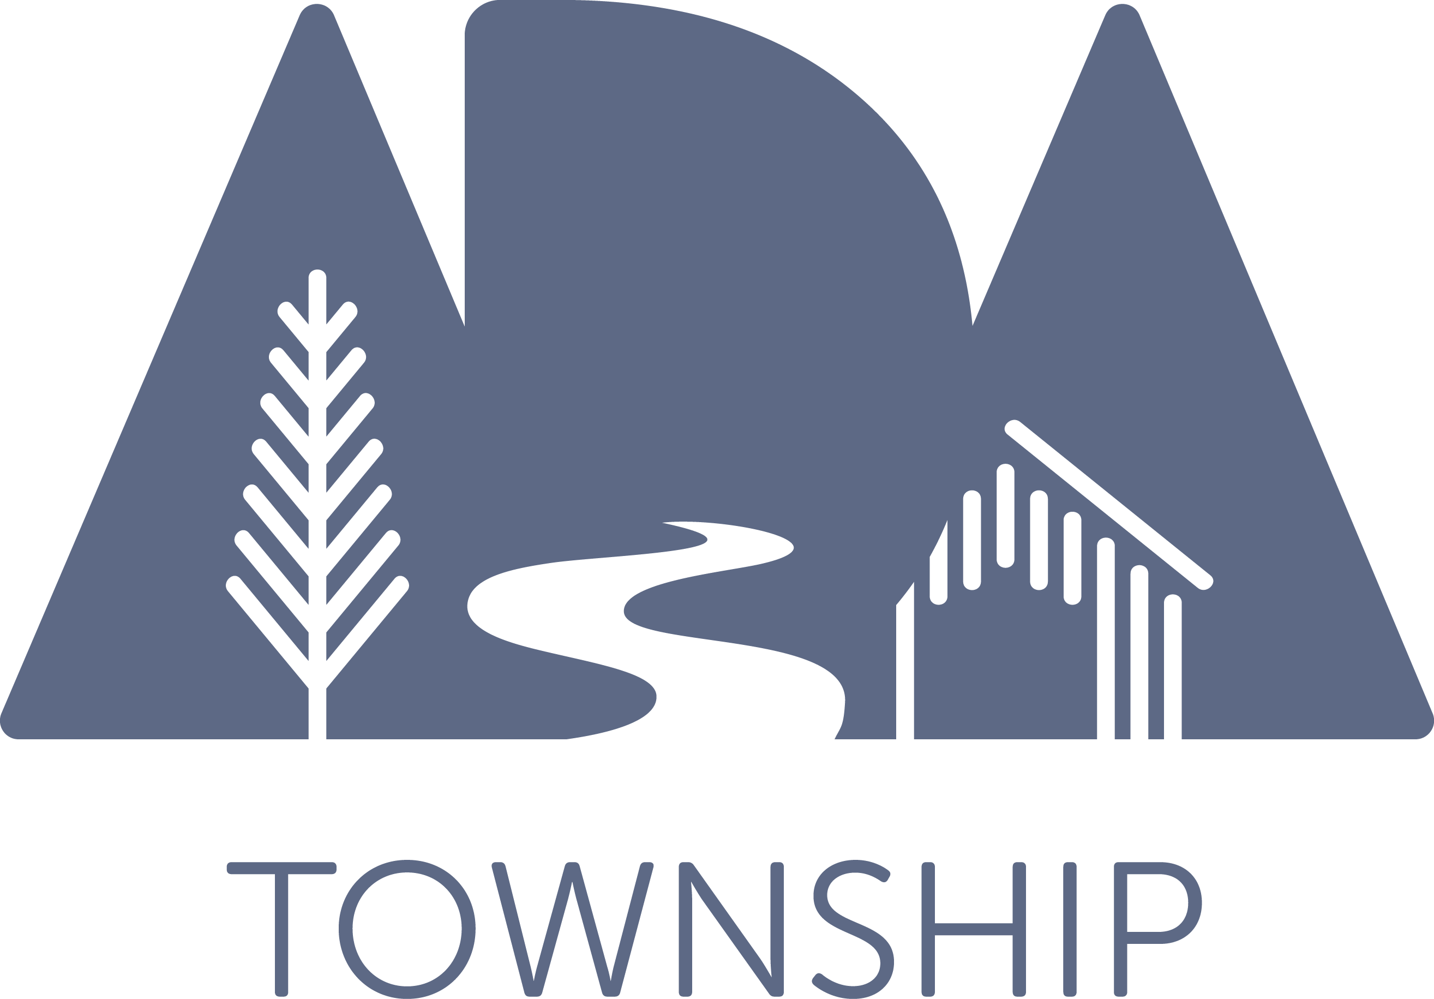

ADA TOWNSHIP DOWNTOWN DEVELOPMENT AUTHORITY
BOARD OF DIRECTORS
MONDAY, AUGUST 10 SEMI-ANNUAL INFORMATIONAL MEETING, 8:30 A.M.

Notice Regarding Electronic Participation:
Pursuant to the Michigan Governor’s Executive Order, in order to protect the public health, this meeting will be conducted via electronic communications. Any member of the public wishing to listen and/or watch the proceedings or provide public comment may do so by using the following internet connection link, or phone number and meeting ID number below:

Participate by desktop computer, laptop or tablet:
Join Zoom Meeting
https://us02web.zoom.us/j/88934239572
Meeting ID: 889 3423 9572

One tap mobile
+13017158592,,88934239572# or
+13126266799,,88934239572#

Participate by phone dial-in audio:
+1 301 715 8592 or
+1 312 626 6799
Meeting ID: 889 3423 9572

AGENDA

- Call to Order/Roll Call

- Information on DDA Events and Projects

- Public Comment

- Adjournment

