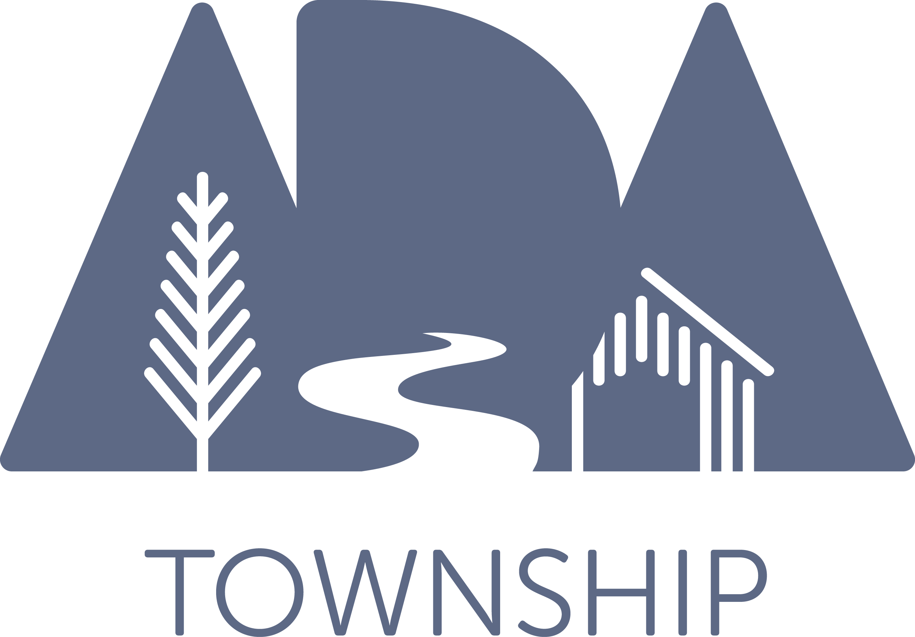

ADA TOWNSHIP DOWNTOWN DEVELOPMENT AUTHORITY
BOARD OF DIRECTORS
MONDAY, OCTOBER 12, 2020 MEETING, 8:00 A.M.
ADA TOWNSHIP OFFICES, ASSEMBLY ROOM
7330 THORNAPPLE RIVER DR SE, ADA, MI

AGENDA

I. Call to Order/Roll Call
II. Approval of Agenda
III. Approval of Minutes of September 14, 2020 Regular Meeting
IV. Consider Approval of Contract for Sidewalk Snow Removal Services for 2020-21 Season
V. Consider Approval of Contract for Holiday Garland Installation and Removal on Downtown Lightpoles
VI. Consider Approval of Contract for Sidewalk Obstruction Joint Grinding
VII. Staff/Committee Updates
a. Discussion of Potential Capital Projects for Capital Improvements Plan Update
b. DDA Financial Report, 9/30/20
VIII. Board Member Comment
IX. Public Comment
X. Adjournment

